JOUR 4251
Psychology of Advertising
3.2 Memory
Make sure to get an In-Class Assignment form before class starts and
write down your name on the form.
Recap Tuesday
● Focal attention
○ Categorization
○ Representativeness heuristic ○ Pioneering advantage
○ Assimilation / contrast
○ Brand personality
● Comprehension
○ Omit comparisons
○ Pragmatic inferences
○ Affirmation of the consequent ○ Juxtaposition
● Elaboration
○ Self schema
○ Meta-cognition
Memory
What do we remember? Do you remember ads you have seen? In-Class Assignment: Question 1
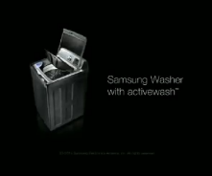

Memory
RECORD - STORE - RETRIEVE - information from the senses Encoding
Is getting information from external stimulus into an internal representation that allows us to retain it in the cognitive system
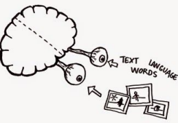
Memory Storage means to retain the information over time
PUSHING SAVE on file
Can be short-term; Can be long-term
Retrieval refers to the processes that allow us to find the information stored in memory.
Forgetting is a set of processes that prevent us from finding it.
The Multi-store model of memory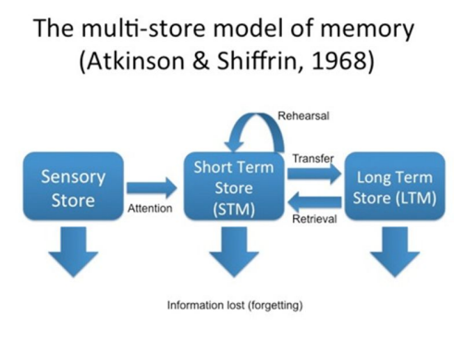
Sensory memory
All senses have memory registers
You can retain it for 18-20 seconds before it either goes away or moves into short-term memory
D R K N S K F W P N X R
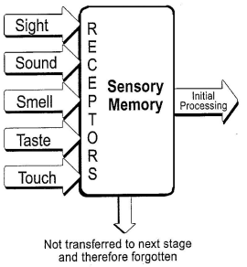
Short-term memory (working memory)
Input from different senses gets integrated with items from long-term memory
Held in conscious awareness
Information can be manipulated
Limited storage ability - it is active and you are consciously aware of it
Verbal rehearsal lengthens the time it stays in short-term and builds up the trace in long-term
Memory test (Question 2)
Memory test (Question 2)
Nine Swap Cell Ring Key Plugs Lamp Apple Table Sway Army Bank Fire Hold Worm Clock Horse Color Baby Sword Desk Keep Find Bird Rock
Memory test (Question 2)
Long-term memory
Unlimited amounts of information
Needs to be encoded semantically or conceptually in order to enter long-term memory
The more you rehearse, the more it is in long-term memory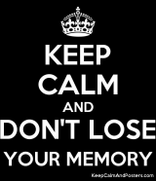
Controversy
That short-term and long-term are different 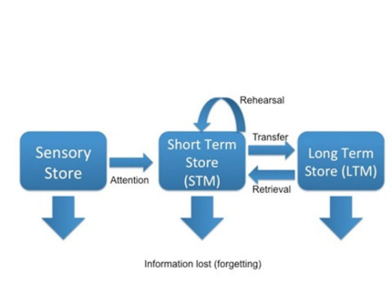
Evidence for multi-storage system
● Speed of retrieval: faster to retrieve from short-term rather than long-term memory
● Capacity: You can’t store as much in short-term than in long-term ● Primacy and recency effects: You remember first and last best ● Different forms of storing the information: encoding process ● Amnesia patients
Problems with multi-storage system 1. Always need to go through short-term memory?
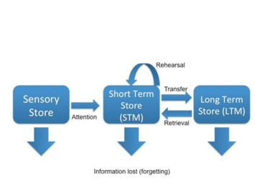
2. Sometimes people don’t remember something that they have seen thousands of times:
Question 3
Draw from memory: - The map of the world OR
- A one dollar bill
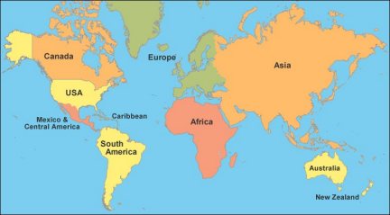
Q4: another memory test!
Answer the following questions:
1. What words did we categorize in the previous class? 2. In what colors were “IPhone” and “Red” written in the word cloud?
Depth of processing
It is not just about repetition. It is also about the level of processing. Remembering comes from processing deeply, rather than superficially.
Thus, depending on what you (are asked to) do with the information can affect how deeply you process it.
RIVER: Is the word in capital letters?
HOUSE: Does the word rhyme with mouse?
WINE: Does the word fit in the sentence: “The man drank a glass of….”
What’s next?
The following things are due February 13 (before class starts!): ● Submit reading response 3 on Chapter 3 (memory)
● Assignment 2 (attention)
○ Hand in on Canvas: Upload Word/PDF document
● Let us know whether you need a laptop for Exam 1 ○ Email your TA

